JavaScript course.

**The very basics of JavaScript**

To run a command over the

**Alert.**

The alert command displays an pop-up window message over the browser with the string we passed as parameter.

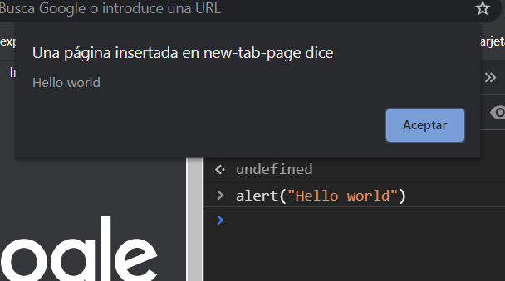

alert(“Insert a string in here”)

**Let**

The let command help us define a variable of the type we want.

**If (condition)**

The if condition help us to make as in other languages.

**=== (Is equal to)**

The triple equal help us to compare between two variables.

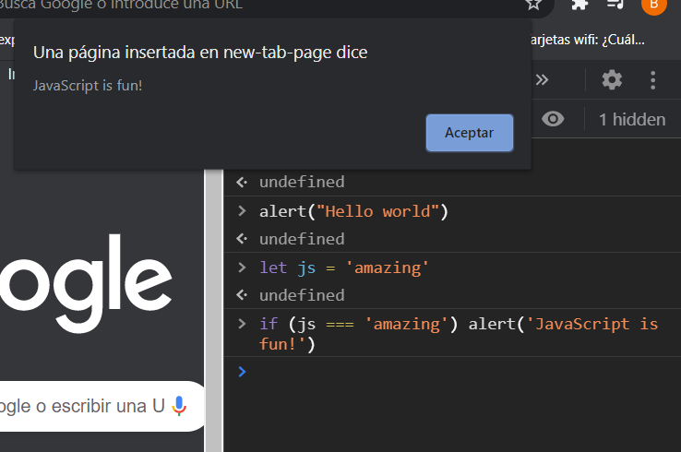

We can do operations over the browser.